
TAPAS
IST-2001-34069
Trusted and QoS-Aware Provision of Application Services

Deliverable D13:
Second Year Evaluation and Assessment Report

Report Version: D13
Report Delivery Date: March 2004
Classification: Public Circulation
Contract Start Date: 1 April 2002 Duration: 36m
Project Co-ordinator: Newcastle University
Partners: Adesso, Dortmund – Germany; University College London – UK; University of Bologna – Italy; University of Cambridge – UK

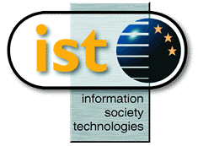 | Project funded by the European Community under the “Information Society Technology” Programme (1998-2002)

